WEF Photo Library Project Request
Guidelines and Recommendations:
- All images must clearly show workers wearing full safety gear appropriate to the situation.
- Images should show inclusivity and diversity in age, gender, nationality, area of expertise, and geographical locations both in the U.S. and abroad (urban, rural, suburban, and non-U.S. locations to represent the complete international scope of WEF membership).
- All images should include background information including names, profession, activity, technology, and location details along with signed release forms.
- Mixed media images with realistic and artistic compositions (shots that clearly show people, processes, and technologies. Unique angles illustrating the artistic and natural aspects of the water management (interesting shapes, natural, and/or industrial elements such as green infrastructure, storm drains, membranes, digesters, aerators, tanks with UV lights, etc.).
- Workforce images:
  - Operators and Maintenance staff at work in all areas of utility operations (eg., water resource recovery facilities, collection systems, labs, sampling, pump stations, turbines for electricity generation, digesters, struvite recovery, land application of biosolids for fertilizer, small plants like lagoons, stormwater pond, wetlands, green infrastructure, etc.)
  - Communications professionals at public and community events (eg., WATER’S WORTH IT®, Pure Water Brewing, town hall meetings, etc.)
  - Young professionals, students, community engagement and outreach activities (eg., community service projects, environmental clean-up days, festivals, utility tours)
  - Data scientists and cybersecurity professionals
  - Instrumentation and SCADA with people
  - Professionals with PPE for safety
  - Engineers, designers, construction personnel on the job with related tools (eg., construction equipment, schematics, blueprints, meetings, etc.)

Specifications:
Digital format, color images.
Please use the highest quality and size setting on your camera. This should result in high-resolution images of at least 300 dpi.
Permission:
Please return attached release form.
Each form grants unlimited usage by WEF and WEF members, and must be signed by:
- any individual appearing in the photographs
- photographer and/or authorized company representative

Example Images
Proper composition, activity, members at work.
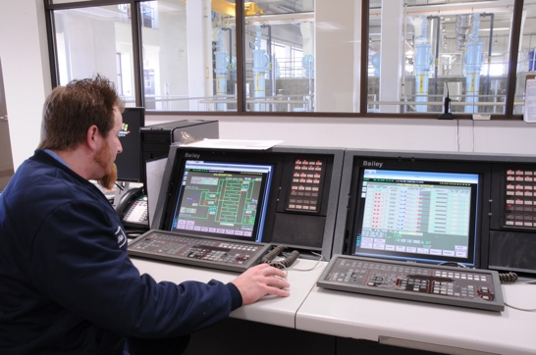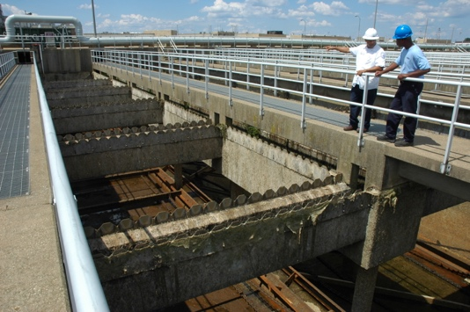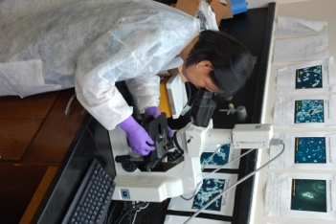

Below is an example of an image we cannot use, as the subject is not using proper protective gear.

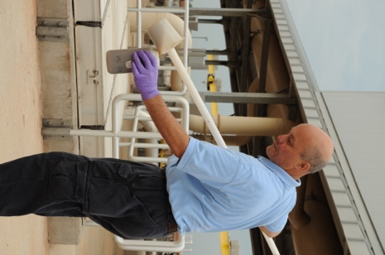

Below is an example of the types of images we can use.
